**Problem introduction**

Implement a recursive method that reads all of the comments in a Reddit thread and makes lists of all the positive, negative and neutral comments.

The purpose of this method is to traverse the replies tree of a given submission,and return three lists: *negative_comments_list*, *neutral_comments_list* and *positive_comments_list*. In other words, you need to traverse all of the replies in the submission, which are structured in a tree-like format.

**Solution design and implementation**

All of the class and most of the methods were already given to us, we only needed to implement the process_comments method using recursion. The class was already formatted in the way it needed to be. The process_comments method just goes through every comment in the thread using recursion sort of like a tree. Once it classifies a comment as either negative, positive, or neutral, it checks the replies and the replies of the replies which is where the recursion occurs.

**Experimental results**

To test the code, I used two different links, one which was very popular and had a lot of comments and one which was one of the most controversial threads in the subreddit. I wanted to see how the number of negative and positive comments compared and also see if it was classifying the comments correctly and appending them to the correct list.

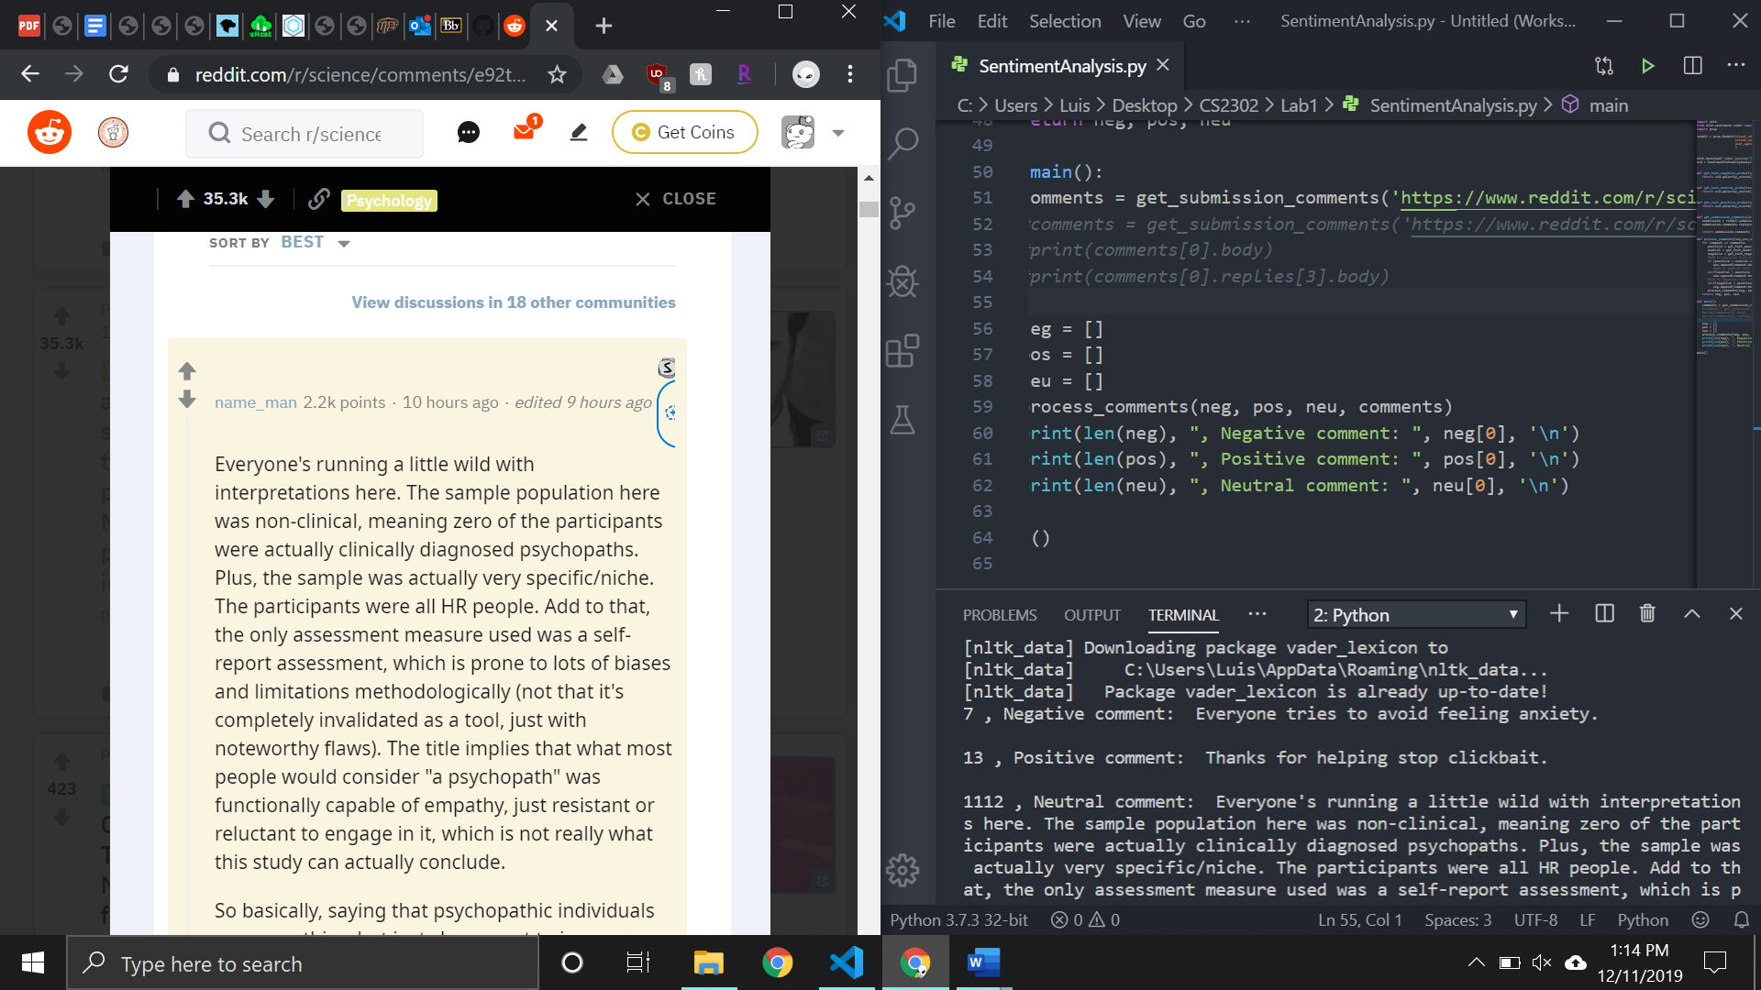

**Conclusion**

Although I don’t know exactly how the algorithm that classifies the comments works, it seems to be very accurate. In this lab, I improved my recursion skills and also learned a little bit more on how to communicate with websites using python.

**Source code**

<https://github.com/lebriones/CS2302/blob/master/SentimentAnalysis.py>